

**SUMMER INTERNSHIP REPORT**

**23rd May 2022-31st July 2022**

TOPIC: **HAND GESTURE RECOGNITION USING DEEP LEARNING**

SUBMITTED BY: **KARTIKEYA SINGH CHAUHAN, DEPARTMENT OF ELECTRONICS AND COMMUNICATION ENGINEERING, DELHI TECHNOLOGICAL UNIVERISTY**

SUBMITTED TO: **DR NARENDRA S. CHAUDHARI, PROFESSOR, COMPUTER SCIENCE AND ENGINEERING, IIT INDORE**

**INTRODUCTION**

**RELATED WORK**

**METHODOLOGY**

* **Prerequisites**

Python 3.5- Python is a general-purpose, high-level, interpreted programming language. Its design concept prioritises code readability by employing heavy indentation. Python is garbage-collected and dynamically typed. It is compatible with a variety of programming paradigms, including structured, object-oriented, and functional programming. Because of its extensive standard library, it is frequently referred to as a "batteries included" language.

Open CV- Open CV is a Python open-source library used for computer vision in applications such as artificial intelligence, machine learning, and face recognition. The CV in Open CV is an acronym for computer vision, which is described as a branch of research that assists computers in understanding the content of digital pictures such as photographs and videos.

* **Procedure**

Strategy for counting fingers

Garb an ROI (Region of Interest)

Calculate a running average background value for 60 frames of video

Once average value is found, then the hand can enter the ROI

Set a ROI and calculate the average running value for some amount of frames.

Then once a hand enters, we can detect change and apply thresholding.

Strategy for counting fingers: Once the hand enters the ROI, we will use a Convex Hull to draw a polygon around the hand.

We will then calculate the centre of the hand against the angle of outer points to infer finger count.

The next step is to use thresholding to grab the hand segment from the ROI.

Now that we have the hand segment, the next step is to actually count the fingers behind held up.

We can do this by utilizing a Convex Hull.

A convex hull draws a polygon by connecting points around the most external points in a frame.

In our case, this set of points is actually just our threshold image of a hand.

Then using a ratio of that distance we create a circle.

Any points outside of this circle far enough from the bottom should be extended fingers.

* **Working**



* **Result**

**One**

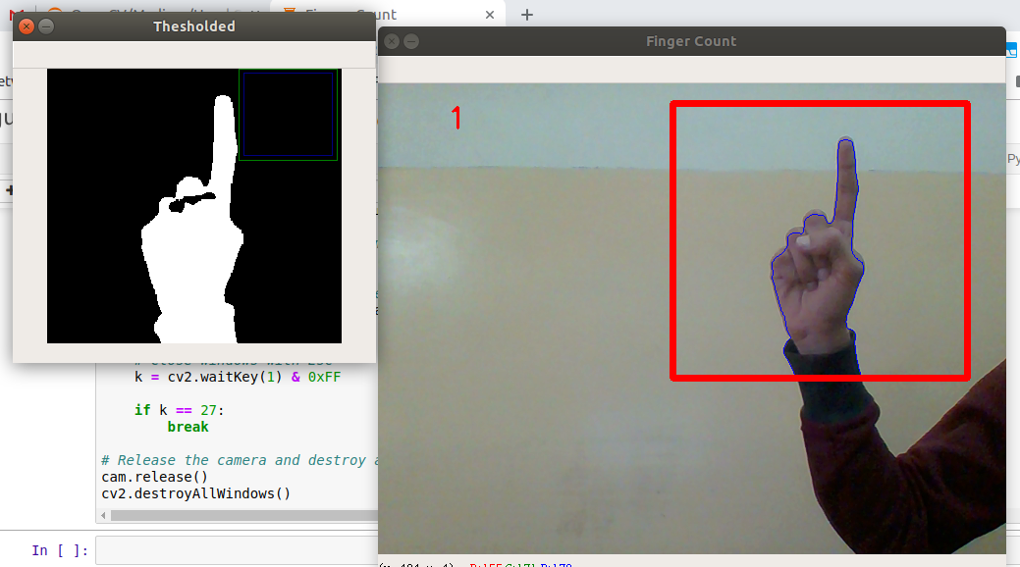

**Two**

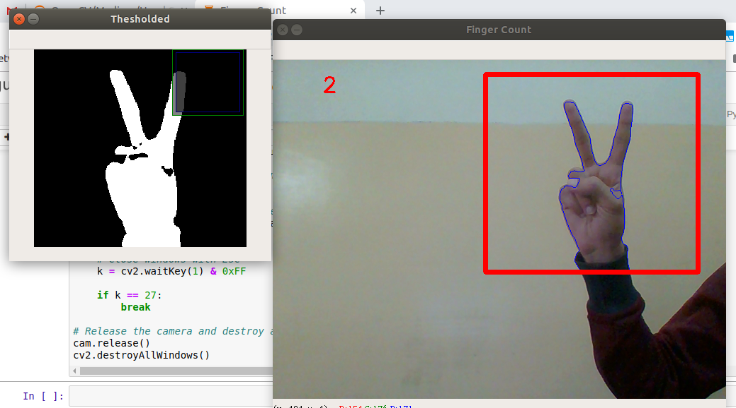

**Three**

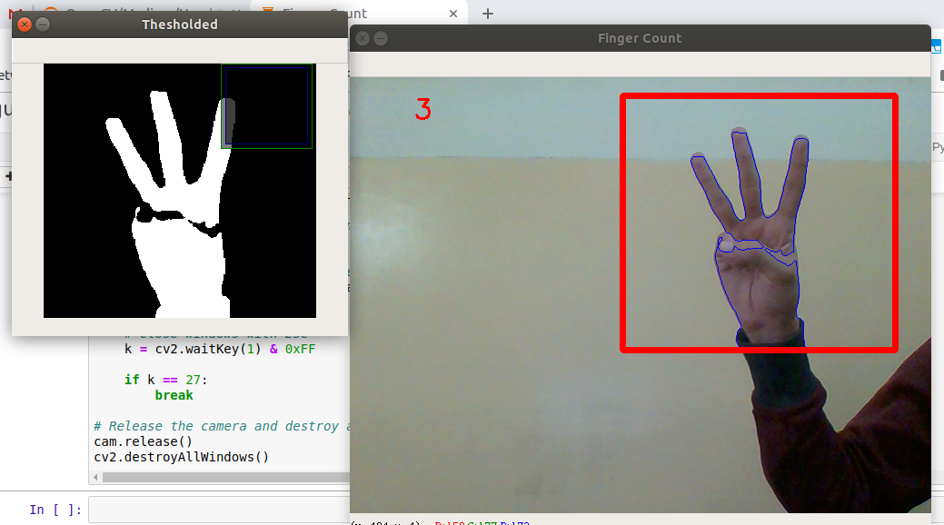

**Four**

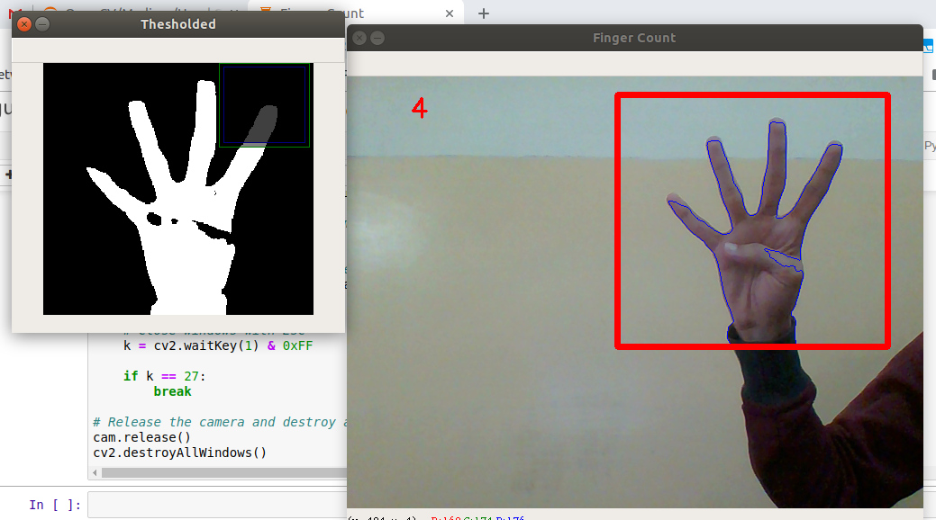

**Five**

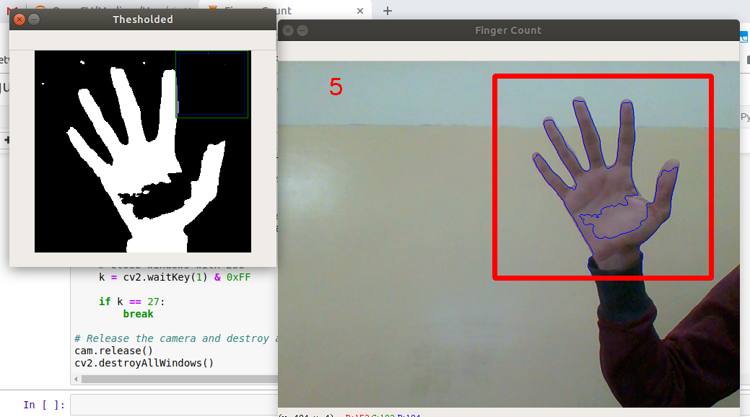

**CONCLUSION**